MED D – Single Transaction Coordination of Benefits (STCOB) Tips and Reminders

Overview
Tips and Reminders
Frequently Asked Questions
Log Activity
Related Documents
Resolution Time
Abbreviations / Definitions

Description: This document provides the guidance to the MED D CCR to determine if a beneficiary is a Single Transaction Coordination of Benefits (STCOB) client.

General Information
Occasionally, the MED D beneficiary will be covered under more than one type of benefit plan. MED D CCRs should utilize the CIF and this job aid to determine if the beneficiary is an STCOB Client in order to research claims in PeopleSafe.

- STCOB beneficiaries do not need to take any action to have their benefits coordinated. This is set up on their behalf by their plan and their employer.
  - STCOB allows for integration of benefits which are payable under more than one plan into one transaction at the pharmacy. Benefits from all sources should not exceed 100% of the total charges.
  - STCOB beneficiaries receive only one ID card. This one ID card will provide coverage for both their Medicare D and the employer provided commercial benefits.

If unable to assist the beneficiary, the Med D CCR will contact the Assist Line for additional support in working toward a first call resolution. Refer to the MED D - SilverScript - Real Time Resolution of Eligibility work instruction.

Top of the Document

Tips and Reminders

The following will assist the CCR when addressing STCOB issues:
From the View Supplemental Financials button on the Claim Financials screen, the CCR can | - View Dispense as Written (DAW) penalties and deductible charged on the secondary account, if any  - View the amount the secondary plan paid on the claim  - View rejection reasons that occurred on the secondary account  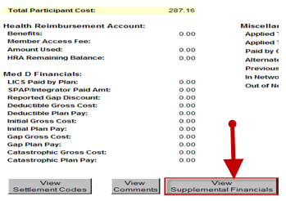
MED D & Medicaid Dual Demographics STCOB | This program will use the STCOB process in place today, with MED D as primary and Medicaid as secondary.  - It will only apply if CVS Caremark has a contract with both clients (Example: the beneficiary has two profiles in PeopleSafe, one for their MED D coverage and one for Medicaid).  - PeopleSafe will display a new field = Dual Demo Eligible on the Prescription Details screen for the All Claims view (not Mail Order view).  - This field will apply ONLY to Medicare D and Medicaid STCOB claims.  Note: For Commercial and traditional STCOB claims, this field will be blank.  - The valid Dual Payer values will be:  - Y - The claim paid/rejected under the primary plan and paid under secondary with no reduced cost sharing.  - Y - Cost Share - The claim paid/rejected under the primary plan and paid under secondary with reduced cost sharing.  - Blank - The claim paid/rejected under primary plan and the secondary was not set as Dual Demo.  Note: The Medicaid Dual Demo field will display whether the beneficiary is Dual Demo or is Not Dual Demo.  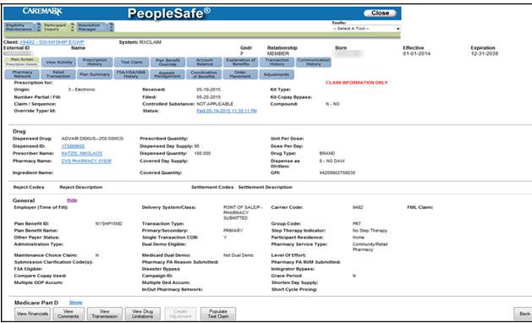  Prescription Details Screen  How to identify a beneficiary with STCOB:  - Review the Supplemental Payer section of the Main screen.  - If there is a Plan Beneficiary ID with a hyperlink, then the beneficiary has STCOB.  - The hyperlink will open the alternate account, allowing you to switch between the primary and secondary accounts.  - When quoting information such as drug coverage and pricing, order status and refills, CCRs must ensure they are working within the beneficiary’s primary account.  - The primary account will always be a SilverScript (SSI) sponsored account. The Client Code will always start with (X9---).  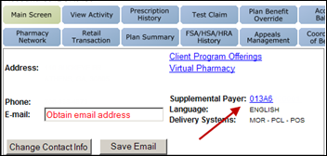
Deductible and Other Accumulations | - To determine how much the beneficiary’s deductible is or to view any other accumulations DO NOT VIEW THE PRIMARY ACCOUNT BALANCES.  - Log into the beneficiary’s Enhanced Wrap Benefit and click the Account Balances tab to view the deductible and other accumulations, such as max out of pocket.
DAW (Dispense as Written) Penalties & High Co-pays | - DAW penalties are ALWAYS charged on the SECONDARY ACCOUNT.  - If there is a high co-pay for a claim, click on the View Supplemental Financials button to see if a DAW penalty or deductible may have been charged.  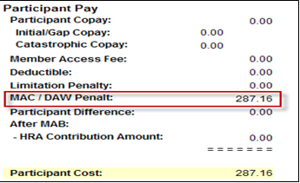  - When performing test claims for brands with generics available, ALWAYS change the May Sub field in the test claim to either MD-NO or PATIENT-NO to get the correct co-pay.  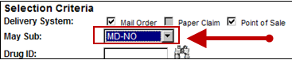
EGWP Accounts: Explaining to Beneficiaries | - The following are tips on how to respond to inquiries from beneficiaries on common EGWP account scenarios:  Scenario 1: The drug wasn’t covered on primary (Med D) but was covered on the Enhanced Wrap Benefit.  - If a drug is not covered on the primary, it might be covered on the Enhanced Wrap Benefit. To quote an accurate copay, you must click on the price link or Details button on the Test Claim screen.  - An example of drug category that this scenario applies to is ED Drugs (other drug categories may apply).  Scenario 2: Drug requires a PA or has Quantity Limits  - To determine if a drug requires PA or has a Quantity Limit:  - Run a test claim and click on Details, then View Financial Details, and then click on the View Supplemental Financials button in PeopleSafe to find the beneficiary’s copay  1. Review Settlement/Reject Code descriptions, making sure to check the response on the Enhanced Wrap Benefit.  2. If a drug rejects on the Primary, it may still pay on the Enhanced Wrap Benefit.  - If the drug has a PA or quantity limit that is Not covered on the Enhanced Wrap Benefit, then a Coverage Determination can be filed. Refer to MED D - Coverage Determinations and Redeterminations (Appeals)   Note: Coverage Determination / Prior Authorization requests should be submitted under the primary carrier when this process is delegated to CVS Caremark (refer to the CIF). The CD/PA process would be for the request to go through the primary carrier and the secondary for review. There could be a denial on the primary if/when the drug is not covered under Part D law. Be sure to check the primary and secondary benefit.  Scenario 3: B vs. D rejection  - If the drug is determined to be Part B (meaning the PA was denied), the drug will be covered by the STCOB Enhanced Wrap Benefit.  - For a list of EGWP clients that allow for a part B override, refer to MED D PHD –SilverScript EGWP Yes Client Coverage Determination Process  - If the drug is determined to be Part D (meaning the PA was approved), the drug will be covered on both the Primary and Enhanced Wrap Benefit.  - The following are examples of B vs. D medications:  - Nebulizer Inhalation Solutions (NEB), such as Albuterol  - Immunosuppressants (IMM), such as Prograf  - Oral Antiemetic (EME), such as Zofran  - Humulin R-500 (INF)  Note: A transition fill is not available for a drug that is rejected for B vs. D determination. The coverage determination must be done in order to determine how the plan will pay for the drug. Refer to MED D - Coverage Determinations and Redeterminations (Appeals).

Top of the Document

Frequently Asked Questions

Question from Beneficiary | Answer from CCR
Why is the medication I received not showing on my Explanation of Benefits (EOB)? | The medication is not reflecting on your EOB because the Medicare portion of your plan did not pay. However, this does not mean that the medication is not covered. The medication is covered by your Employer on the secondary plan.
Why did I receive a coverage denial letter for my medication if it was approved? | The medication was denied on the Medicare portion of your plan. We are required by CMS to provide documentation of that denial. However, this does not mean that the medication is not covered. The medication is covered by your Employer on the secondary plan.

Top of the Document

Log Activity
1309 - Coordination of Benefits

Top of the Document

Resolution Time
Information = Immediate

Top of the Document

Related Documents
Abbreviations/Definitions: Abbreviations / Definitions

Top of the Document
Not to Be Reproduced or Disclosed to Others without Prior Written Approval
ELECTRONIC DATA = OFFICIAL VERSION – PAPER COPY = INFORMATIONAL ONLY

